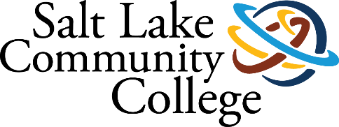 | VETERANS SERVICES
2019-2020 ANNUAL ASSESSMENT
SUMMARY OF RESULTS

Project (Assessment) Title: VITAL Peer Mentor Program

Offering college students and student veterans alike with the availability and convenience to a peer mentor can be an effective tool in addressing the major obstacles in semester retention and graduation. Any student at Salt Lake Community College would be fortunate to have that accessibility and academic support each semester.

The VITAL peer mentor program is housed to offer encouraging academic outcomes by providing added personal interaction, attention to student learning and academic focus for student veterans in succeeding.

Imagine learning, after the completion of a semester, a student has failed a class or two, or the entire semester is a loss; this occurance is difficult to comprehend. This current situation will be restructured with the peer mentor intervening early within the semester. Recurrent student interaction is a significant, critical and necessary variable that can and will affect student outcomes and results.

Upon entering college, students influence their specific educational settings by the level of experiences immediately offered to them. The student is sporadic in seeking out assistance within such a large and oft times difficult to manage college campus. Directly reaching out to students is critical upon being admitted to a higher educational institution.

The VITAL Peer Mentor Program is in its first 6 months of service. A 1-year Boeing Grant has made it possible to house a fulltime peer mentor at SLCC Veterans Services. This program is a valuable educational platform in providing the means of supporting student development, encourages and shapes individual student experience, resulting in academic progress and success.

This assessment will research the successes and outcomes of peer mentoring. Successful peer mentoring structure involves in person, one-on-one affiliation between the student and the peer mentor. Does personal student contact, early intervention and academic support enhance semester retention and completion?

College-wide Strategic Goal: Retention and Graduation

Mentor new and continuing student veterans each semester up through graduation.

The VITAL Peer Mentor program is a retention strategy and an approach to help student veterans navigate campus life, support individual best practices, be attentive to academic performance issues and to facilitate student retention each semester. Graduation is not attained without individual semester retention.

Assessment Overview

The student veteran faces challenging roadblocks and readjustment issues which hinders semester completion.
Issues such as:

- Transiting to Civilian Life and the wide range of stress-related Educational Rigors
- First generation college student and student veteran combined
- Relating to younger students in the classroom
- Not Belonging – Feeling Alone
- Coming from a regimented environment to a college atmosphere; no direction is offered
- Readjustment Issues – No individual student guidance and semester support
- Mental and physical injuries modes Self-Confidence into Lack of Confidence
- Possible academic weakness due to being on tour/duty for many years
- Academic Advising failures – Academic Advisors not sure the direction or classes needed
- Unknown VA on campus services or academic direction – too anxious or uneasy to enquire
- Unclear of profession or direction

Student Veteran Challenges
Student veterans enter college pre-packaged with various and always different roadblocks and challenges; therefore, transitioning from military to campus life enhances these barriers. Military students witness a higher risk for a semester drop or withdraw, and this trend should never go unnoticed.
As with many nationally higher educational institutions, a failed semester isn’t noticed until after semester completion, or if it’s even observed. Over half of our nation’s military students are not completing the degree they set out to achieve.

Methodology (Plan/Method)
Peer Mentors step-by-step support and early intervention for each new and continuing student.
SLCC Veterans Services Peer Mentor is in contact and observing each student veteran throughout each semester, assisting in eliminating drops and withdrawals by intervening early.
Individual contact via phone and in-person appointment is immediately pursued by the below:
- Immediate contact with the new student applicant
- Personal phone call within 24 hours to welcome and set up peer mentor meeting
- Director and Welcome Letter along with a 6 Step Guide to Registration sent to each student the same day the application has been submitted
- Setup mandatory one-on-one Peer Mentor counseling session
- Discuss any roadblocks and challenges that will hinder semester completion
- Refer outside VA services and SLCC services as needed
- Several times throughout the semester, students are personally contacted offering academic support.
- Mid-Semester grades are requested from instructors that have a student veteran in their class. Any student with a C or lower is scheduled a mandatory peer mentor meeting to that will consist in supporting the student with their academics with semester completion.
- Assign tutors, DRC, Academic Advising when needed. Any SLCC department or VA. organization that can assist a student in semester completion is scheduled with that entity.
- An after-semester review is offered for each student
- Assisting with enrollment for the following semester
- Reviewing academic performances
- Supporting in outreach assistance

Results/Findings - Below Charts Outline Results
Retention Rate is measured by the number of students who registered for a minimum of 2 semesters in a row. Student veteran retention has increased since the implementation of the fulltime Peer Mentor.

Peer Mentor Activity
The Peer Mentor documents daily activity each semester. Results and Findings are derived from this activity:
- Initial Intakes
- Outreach Attempts
- Outreach Contacts
- Referrals Made outside of Office
- Reoccurring Appointments
- Team Hours
- Students with Ongoing Care
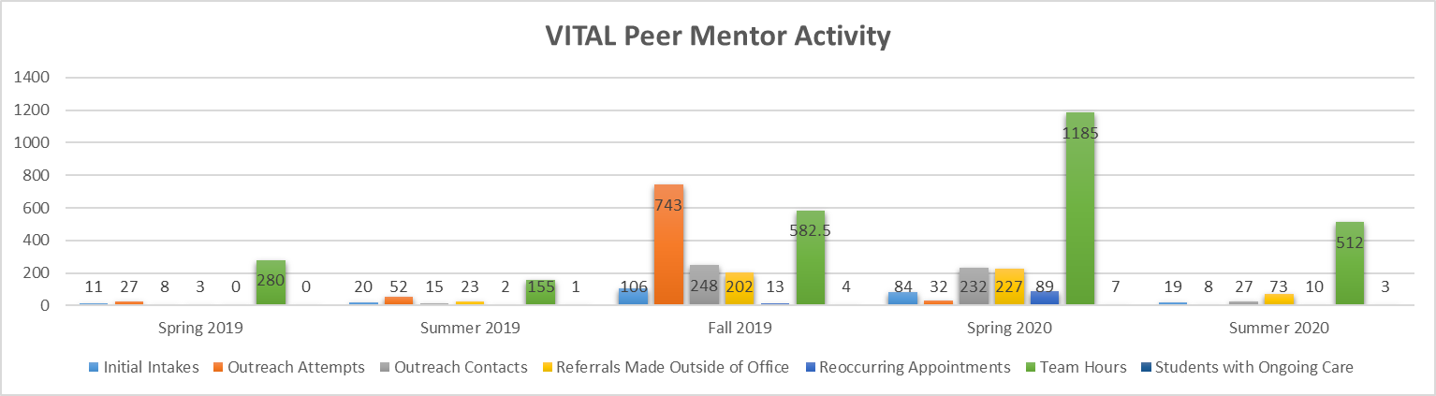
VA Benefits Referrals (Outside the Veterans Services Office)
VA Benefits Referrals below offer the student veteran security in knowing that the Peer Mentor knows these assistance programs and how to bridge them to the student to receive assistance, guidance and help. The Peer Mentor’s knowledge will communicate to student veterans there is someone on-campus they can trust.

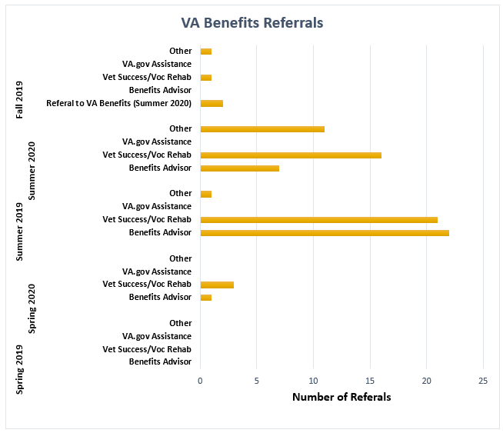

Community Services Referrals

Community Services Referrals assists student veterans with community organizations. This helps empower each student to learn about their own community and what is offered.

VA Medical Services Referrals

Student veterans have comfort with an extra level of care. Each student has the VA medical center close by to assist in different type of needs.

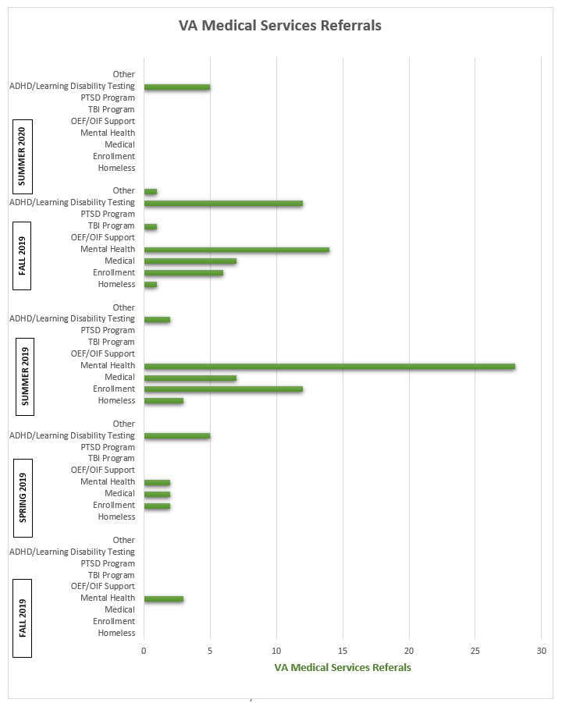

Findings / Overview

Salt Lake Community College Veterans Services seeks to always employ a peer mentor that’s available and accessible each semester. This pledges to students that they are not alone in dealing with educational downfalls and emotional challenges. We have witnessed that dedicated and quality mentoring enhances academic ability and offers a supportive educational environment.

From the first student peer mentor orientation to the end of the first semester, each student has created a meaningful affiliation with the peer mentor. Each student feels more connected and involved on-campus which can in due course improve student retention and graduation outcomes.

Peer Mentoring is a very important asset for the college, and a valuable support for students at critical points in the students’ educational journey. Peer Mentors are reliable, trustworthy, patient, and, an excellent listener.

The Peer Mentoring program has created a busier Veterans Service Center. A busier Veterans Service Center displays student confidence. Student self-assurance and confidence solidifies semester completion and retention which eventually equals graduation.

Our findings through tracking students that work with their Peer Mentor, the following semester enrollment percentages have increased in part of gaining educational confidence, navigating studying skills and seeking assistance more willingly on their own cognizance.

Action Plan (Use of Results/Improvements/Call to Action)

Improvements
How many student veterans are not working with a Peer Mentor?
- Create report of student veterans not meeting with a Peer Mentor.
- What is the reason(s) they are not meeting?

Increase the number of students that meet with a Peer Mentor
- New student veterans must meet with Peer Mentor
- Peer Mentor meeting is mandatory
- Veterans Services Orientation, GI Bill benefits, registration, requesting certification to receive GI Bill funding for each semester, SLCC and VA amenities and services discussed
- Student veterans that do meet with a Peer Mentor, delays in funding are minimal, more confidence in campus routine, class management and reaching out for assistance and support with the Peer Mentor

- New student does not meet with a Peer Mentor
- A noticeable difference in Housing Allowance, Tuition and Book Stipend funds are delayed for those students who do not meet with a Peer Mentor
- All new students receive a letter before their initial Peer Mentor meeting outlining the positives of having a Peer Mentor student affiliation
- Outlining: GI Bill tuition / Housing / Book Stipend
- Tutoring assistance / SLCC and VA referrals
- Current psychological/physical assistance for semester success

Following up with SLCC Department or VA referrals:
- Did the student contact the SLCC Department or VA referral?
- Initiate first contact with the VA for the student?
- Explore the possibilities and procedures if Peer Mentor can setup initial contact
- Are referral meetings successful?
- If so, how do they align with semester completion and retention?
- If not, how do we improve tangible and positive outcomes?

CALL TO ACTION
- Establish virtual meetings with the Peer Mentor and online students. Currently a phone call meeting is established if no virtual capability is available.
- Create a questionnaire for students that do not meet with a Peer Mentor. Learn from student input for future student veterans meeting with a Peer Mentor

Other Notes

A Peer Mentor has the capacity to increase retention in notable ways. A very simple concept that should be practiced more in higher education settings is; Someone cares about my education and are willing to assist and guide when needed.

